Program Popestrimo šolo 2016-2021 sofinancirata Ministrstvo za šolstvo Republike Slovenije in Evropski socialni sklad.

Devil's tower

The most interesting jewels of Slovenia's landscape are very often those that are shrouded in a veil of mystery. One such place is the Devil's Tower in Soteska, a little village between two forested plateaux. The tower has stood here for over three hundred years, a place of entertainment and sinful pleasure.

The building, which has excellent acoustics, is today used as a venue for concerts and art exhibitions, leading visitors into the universe of medieval or modern music and art.

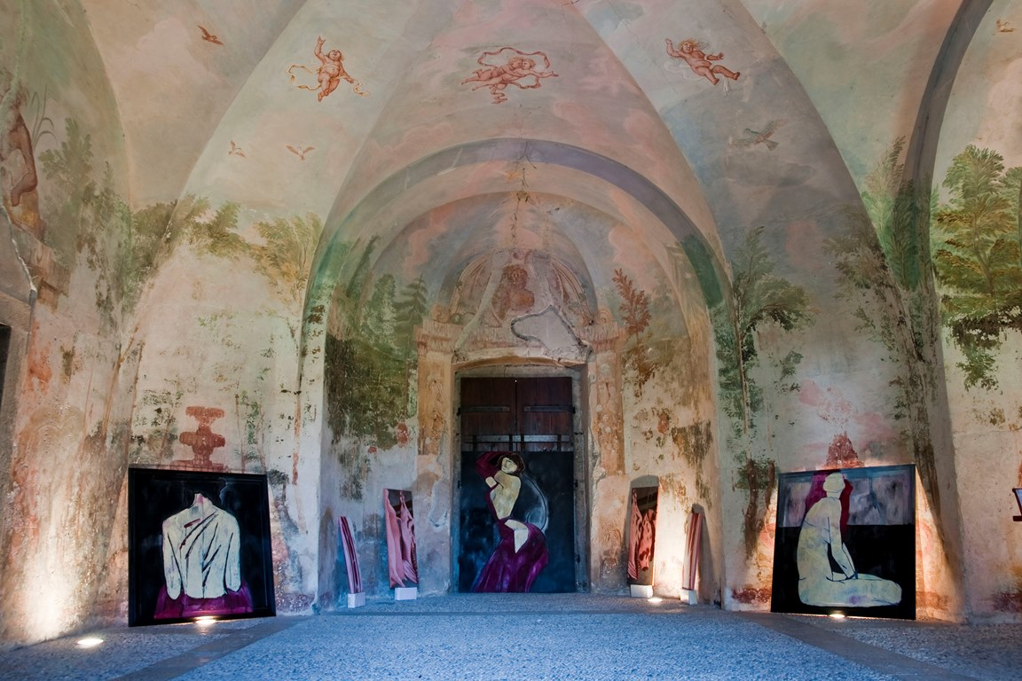

The folk tradition explains that the unusual name of the garden pavilion is linked to the hedonistic entertainments, regularly organized by the Lords of the Castle. Although these entertainments in the pavilion were only a reflection of the lifestyle of the aristocracy during the Rococo period, among the villagers they created an impression of sinfulness and therefore they named the pavilion Hudičev trn (DEVIL'S TOWER).

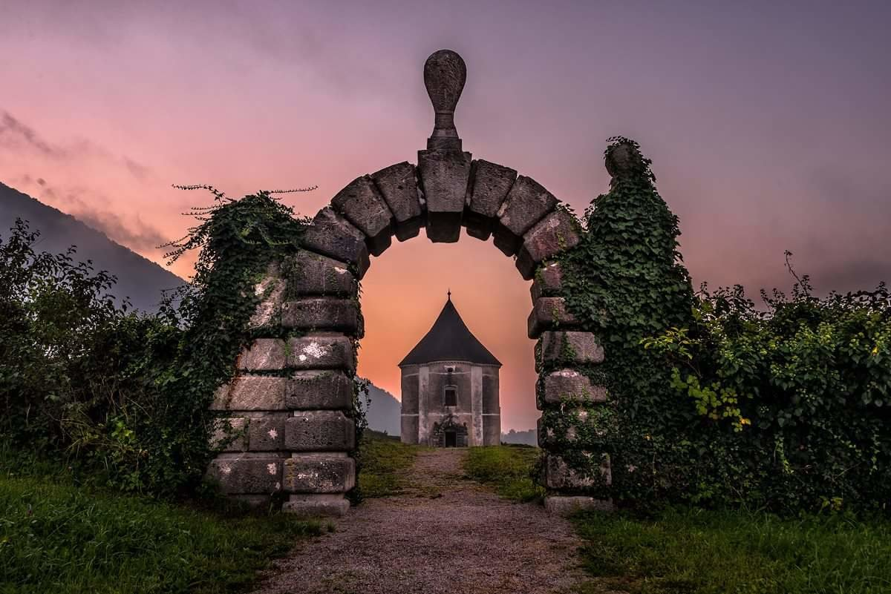

This tower is surrounded by many legends and rumors about hauntings. Some people believe that there lives a devil. They hear strange noises and screams of girls who were raped by the lord.

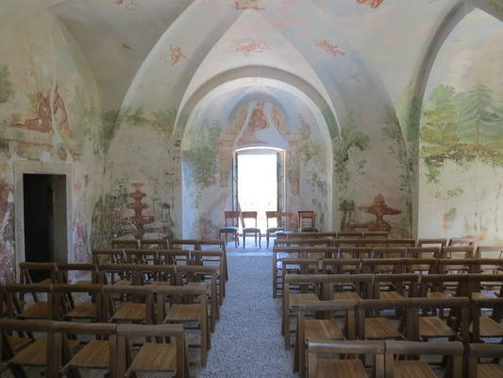

written by: Sanja Kodelič, 7. a